Exercise – 01:

function App(){

  return (

    <h1>Welcome the first session of React</h1>

  );

}

export default App;

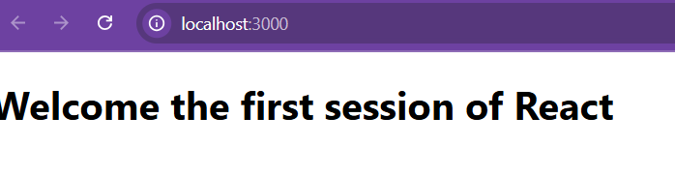

Exercise – 02:

/src/Components/

**About.js:**

import React,{Component} from 'react';

class About extends Component{

    render(){

        return(

        <div>

            <h3> Welcome to the About Page of Student Management Portal </h3>

        </div>

        );

    }

}

export default About;

**Contact.js:**

import React,{Component} from 'react';

class Contact extends Component{

    render(){

        return(

        <div>

            <h3> Welcome to the Contact Page of Student Management Portal </h3>

        </div>

        );

    }

}

export default Contact;

**Home.js:**

import React, { Component } from 'react';

class Home extends Component{

    render(){

        return (

        <div>

        <h3>Welcome to the Home Page of Student Management Portal</h3></div>

        );

    }

}

export default Home;

**App.js:**

import logo from './logo.svg';

import './App.css';

import Home from './Components/Home';

import About from './Components/About';

import Contact from './Components/Contact';

function App() {

  return (

    <div className="container">

      <Home />

      <About />

      <Contact />

    </div>

  );

}

export default App;

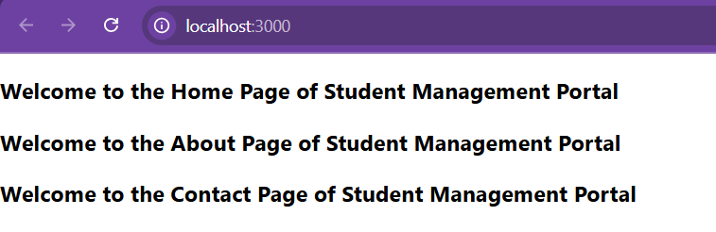

**Exercise – 03:**

**/src/Components/**

**CalculateScore.js**

import logo from './logo.svg';

import './App.css';

import Home from './Components/Home';

import About from './Components/About';

import Contact from './Components/Contact';

function App() {

  return (

    <div className="container">

      <Home />

      <About />

      <Contact />

    </div>

  );

}

export default App;

**App.js**

import logo from './logo.svg';

import './App.css';

import  CalculateScore  from './Components/CalculateScore';

import './mystyle.css'

function App() {

  return (

    <div>

      <CalculateScore Name={"Steeve"}

      School={"DNV Public School"}

      total={284}

      goal={3}/>

    </div>

  );

}

export default App;

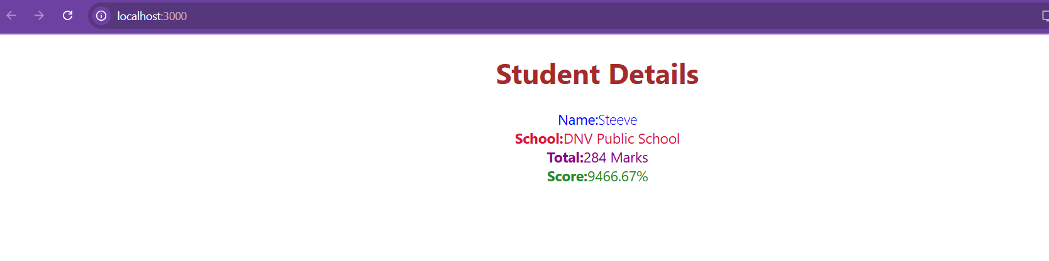

**Exercise – 04:**

**/src/Post.js**

class Post {

    constructor(id, title, body) {

        this.id = id;

        this.title = title;

        this.body = body;

    }

}

export default Post;

**/src/Posts.js**

import React from 'react';

import Post from './Post';

class Posts extends React.Component {

    constructor(props) {

        super(props);

        this.state = {

            posts: [],

        };

    }

    loadPosts() {

        fetch('https://jsonplaceholder.typicode.com/posts')

            .then(response => response.json())

            .then(data => {

                const postObjects = data.map(item => new Post(item.id, item.title, item.body));

                this.setState({ posts: postObjects });

            })

            .catch(error => {

                console.error('Error fetching posts:', error);

                alert('Error fetching posts');

            });

    }

    componentDidMount() {

        this.loadPosts();

    }

    componentDidCatch(error, info) {

        console.error('Error caught in componentDidCatch:', error, info);

        alert('An error occurred: ' + error.message);

    }

    render() {

        return (

            <div>

                <h1>Blog Posts</h1>

                {this.state.posts.map(post => (

                    <div key={post.id}>

                        <h2>{post.title}</h2>

                        <p>{post.body}</p>

                        <hr />

                    </div>

                ))}

            </div>

        );

    }

}

export default Posts;

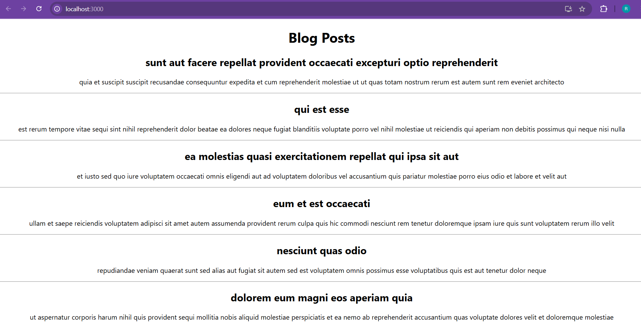

**Exercise – 05:**

**/src/App.css**

.box{

  width: 300px;

  display: inline-block;

  margin: 10px;

  padding-top:10px;

  padding-bottom:10px;

  padding-left: 20px;

  padding-right: 20px;

  border: 1px black;

  border-radius: 10px;

}

:global(dt) {

  font-weight: 500;

}

**CohortDetails.js**

function CohortDetails(props) {

    const headingStyle = {

        color: props.cohort.currentStatus.toLowerCase() === 'ongoing' ? 'green': 'blue',

    }

    return (

        <div className="box">

            <h3 style={headingStyle}>

                {props.cohort.cohortCode} -

                <span>{props.cohort.technology}</span>

            </h3>

            <dl>

                <dt>Started On</dt>

                <dd>{props.cohort.startDate}</dd>

                <dt>Current Status</dt>

                <dd>{props.cohort.currentStatus}</dd>

                <dt>Coach</dt>

                <dd>{props.cohort.coachName}</dd>

                <dt>Trainer</dt>

                <dd>{props.cohort.trainerName}</dd>

            </dl>

        </div>

    );

}

export default CohortDetails;

